**DEPARTMENT OF INFORMATION SCIENCE & ENGINEERING**



***Project Based Learning Report on***

**Parking Management App for Android**

**BACHELOR OF ENGINEERING**

**in**

**INFORMATION SCIENCE AND ENGINEERING**

**by**

|  |  |
| --- | --- |
| **Name** | **USN** |
| Mr. PRAJWAL R | 1BY18IS084 |
| Mr. PRASHANTH R | 1BY18IS089 |
| Mr. RAGHAVENDRA K M | 1BY18IS093 |
| Ms. SUGANDHA SINHA | 1BY18IS119 |

*Under the Guidance of*

Prof. S Mahalakshmi

Assistant Professor



**BMS INSTITUTE OF TECHNOLOGY& MANAGEMENT**

BENGALURU-560064

2020-21

**BMS INSTITUTE OF TECHNOLOGY& MANAGEMENT**

YELAHANKA, BENGALURU- 560064

**DEPARTMENT OF INFORMATION SCIENCE & ENGINEERING**



**CERTIFICATE**

This is to certify that the Project Based Learning Entitled “**Parking Management**

**App for Android”** is a bonafide work carried out by **Mr. PRAJWAL R (1BY18IS084), Mr. PRASHANTH R (1BY18IS089), Mr. RAGHAVENDRA K M (1BY18IS093), Ms. SUGANDHA SINHA (1BY18IS119)** during the academic year 2020-21. It is certified that all corrections/suggestions indicated for the Internal Assessment have been incorporated in the report deposited in the departmental library.

|  |  |  |
| --- | --- | --- |
| _____________________ |  | _____________________ |
| Signature of the guide |  | Signature of the HOD |
| Prof. S Mahalakshmi |  | Dr. Pushpa S K |

**ABSTRACT**

It is very common waiting outside a parking lot and looking if any space available in there, this overtime will be irritating and time consuming especially in traffic rich cities like Bangalore, Delhi etc.

Everyone would have frequently experienced that they park their vehicle somewhere beside the road and by the time they return the vehicle is gone, this would have been the worst day for a person having plans for the day. Thus, knowing the availability of parking space in advance would help people to plan for the same and save the time which would have been spent in looking for a spot in the lot. The parking fee is also a major concern of people, wherein many of them would not know the cost of parking per hour basis and which would cause them to pay more than the actual fee for it.

This Parking Management App is a parking solution which to solve the above problems by providing the user with the available space in the lot and calculate the amount accurately with the parameters of entry time and exit time. It will also keep history of all the vehicles parked at any parking spot with specific date and time.

**ACKNOWLEDGEMENT**

We heartily thank our Principal Dr. Mohan Babu G N, BMS Institute of technology and Management for his constant encouragement and Inspiration in doing the project.

We heartily thank our Head of the Department Dr. Pushpa S K, Dept of Information Science and Engineering, BMS Institute of technology and Management for her constant encouragement and Inspiration in doing the project.

We heartily thank our project coordinator, Prof. Shwetha M S, Professor, Dept. of Information Science and Engineering, for her constant follow-up and advice throughout the project work.

We gracefully thank our project guide Prof. S Mahalakshmi, Assistant Professor, Dept. of Information Science and Engineering for her constant support, guidance and inspiration for the project.

**TABLE OF CONTENTS**

|  |  |  |
| --- | --- | --- |
| **CHAPTER** | **TOPIC** | **Pg. No.** |
| 1 | Introduction   * 1. Introduction   2. Motivation   3. Objectives |  |
| 2 | Background   * 1. Introduction   2. Algorithm   3. Design/Methods   4. Results/Discussion   5. Applications |  |
| 3 | Conclusion  References |  |

**List of Figures/Tables**

|  |  |  |
| --- | --- | --- |
| **Figure No.** | **Name of Figures** | **Page No.** |
| 1.5 | Android architecture |  |
| 1.6 | Android components |  |
| 2.1.1 | Flow of the Activities in Application |  |
| 2.2 | The design of Application |  |
| 4.1.1 | Home Activity |  |
| 4.1.2 | Admin Home Activity |  |
| 4.1.3 | Login Activity |  |
| 4.1.4 | Register Activity |  |
| 4.1.5 | Available Slots Activity |  |
| 4.1.6 | Parked Vehicles Activity |  |
| 4.1.7 | Parked History Activity |  |
| 4.1.8 | Add Vehicle Activity |  |
| 4.1.9 | Remove Vehicle Alert Dialog |  |
| 4.1.10 | Vehicle Exit Activity |  |
| 4.1.11 | Add Vehicle Alert Dialog |  |
| 4.1.12 | Forgot Password Alert Dialog |  |

|  |  |  |
| --- | --- | --- |
| **Table No.** | **Name of Tables** | **Page No.** |
| 5.0 | Application Test |  |

**CHAPTER-1**

**INTRODUCTION**

**1.1 INRODUCTION**

With the increase in use of private vehicle in recent years, the problem of car parking has raised in busy and big cities of the world. In crowded cities of the world, mostly a person must spend a lot of time in finding the vacant parking lot.

As an important component of traffic system, parking management system is playing an important role and affecting people’s daily life. By detecting and processing the information from parking lots, smart parking systems allows driver to obtain real-time parking information and alleviates parking contentions.

A Smart Parking Management system is a parking solution which is embedded into parking spots to detect whether parking bays are free or occupied through real-time data collection. It will not only help in generating bill for parking of car but will also keep record of all the vehicles parked at any parking spot with specific date and time.

**1.2 MOTIVATION**

**SMART CITY:**

* Parking Management App for Android can be used to manage parking problems.
* It can be used to automate park billing system.
* It can also be used to display the available space in parking.

**1.3 OBJECTIVES**

* To develop an intelligent, user friendly automated car parking system which reduces the manpower and traffic congestion.
* To improve the performance and satisfy the need of free parking lot.
* To reduces the time wastage in finding the vacant parking lot.

**CHAPTER-2**

**BACKGROUND**

**2.1 INTRODUCTION**

**2.1.1 INTRODUCTION TO MOBILE APPLICATION DEVELOPMENT**

Mobile application development is the process to making software for Smartphone and digital assistants, most commonly for Android and iOS. The software can be preinstalled on the device, downloaded from a mobile app store or accessed through a mobile web browser. The programming and markup languages used for this kind of software development include Java, Swift, C# and HTML5.

Mobile app development is rapidly growing. From retail, telecommunications and e-commerce to insurance, healthcare and government, organizations across industries must meet user expectations for real-time, convenient ways to conduct transaction and access information. Today, mobile devices- and the mobile applications that unlock their value-are the most popular way for people and business to connect to the internet. To stay relevant, responsive and successful, organizations need to develop the mobile applications that their customers, partners and employees’ demand.

**2.1.2 WHAT IS MOBILE APP?**

A mobile application or mobile app is a computer program or software application designed to run on a mobile device such as a phone, tablet, or watch. Apps were originally intended for productivity assistance such as email, calendar, and contact databases, but the public demand for apps caused rapid expansion into other areas such as mobile games, factory automation, GPS and location-based services, order-tracking, and ticket purchases, so that there are now millions of apps available. Apps are generally downloaded from application distribution platforms which are operated by the owner of the mobile operating system, such as the App Store (iOS) or Google Play Store. Mobile applications often stand in contrast to desktop applications which are designed to run on desktop computers, and web applications which run in mobile web browsers rather than directly on the mobile device. Mobile App has many advantages like within a short app we can communicate a lot of information to the client/customers and even it is an ease of access to client/customer for services update or sale/purchase activity.

**2.1.3 INTRODUCTION TO ANDROID STUDIO**

Android Studio is the official Integrated Development Environment (IDE) for Android app development, based on IntelliJ IDEA. On top of IntelliJ’s powerful code editor and developer tools, Android Studio offers even more features that enhance your productivity when building Android apps, such as:

* A flexible Gradle-based build system
* A fast and feature-rich emulator
* A unified environment where you can develop for all Android devices.

Apply Changes to push code and resource changes to your running app without restarting your app. Code templates and GitHub integration to help you build common app features and import sample code. Extensive testing tools and frameworks. Lint tools to catch performance, usability, version compatibility, and other problems. C++ and NDK support. Built-in support for Google Cloud Platform, making it easy to integrate Google Cloud Messaging and App Engine.

Android Studio provides a unified environment where we can build apps for Android phones, tablets, Android Wear, Android TV, and Android Auto.

**2.2 ALGORITHM**

Fig. 2.2.1 Algorithm

**Step 1:** The HomeActivity will be the first activity triggered on opening of app, here there will be two options i.e., the users can view the parking spaces and the admin can login.

**Step 2:** If it is user then the control flows to AvailableSlotsActivity where the details of all the parking slots i.e., the name of the slot, location, available and total slots will be displayed in a list view.

**Step 3:** If the admin has already registered, they click on login then the LoginActivity will be invoked where they will have to provide their credentials to login, else the admin can register by clicking on register.

**Step 4**: After login, the admin will be displayed with the AdminHomeActivity where the details of the admin will be displayed, and he will be given an option to enter vehicle or view history.

**Step 5:** If the admin clicks on parked vehicles, he will be directed to ParkedvehicleActivity where the vehicles present in the lot will be displayed in a list view and he will be given an option to enter a vehicle, after entering vehicle, the details are validated with help of regular expression and saved to the database.

**Step 6:** If the admin clicks on a list containing a vehicle present in the lot, then the control flows to BillActivity where the amount will be calculated and displayed to the admin.

**Step 7:** If the admin clicks on history, he will be directed to ParkedHistoryActivity where the details of previously parked vehicles will be displayed in a list view.

**2.3 DESIGN**

**Activities:**

An activity represents a single screen with a user interface, in-short Activity performs actions on the screen. If an application has more than one activity, then one of them should be marked as the activity that is presented when the application is launched, which is done in the manifest file.

The project has 9 activities, starting from “HomeActivity”, which is the first screen visible to the users once they open the app, The clicks on the views will lead to trigger of respective activities, the flow is represented below:

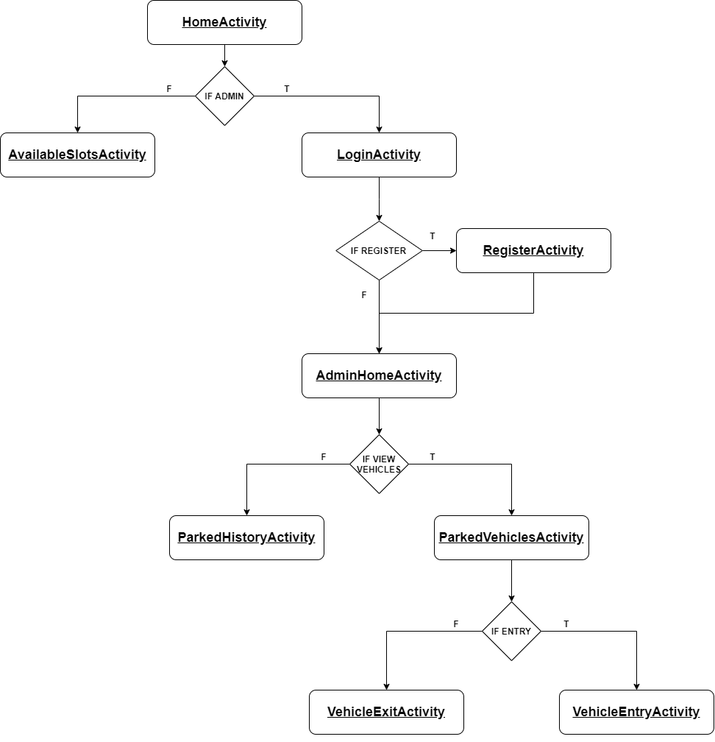

Fig. 2.3.1 Flow of Activities in Application

**Views:**

View is the basic building block of UI (User Interface) in android. View refers to the android.view.View class, which is the super class for all the GUI components.

The app contains Text View, Image View, Button, Edit Text, List View, Progress Bar, Card View which helps in achieving the flow of Activities and design the layout responsively.

Text Views are used to display the field labels and the details of the Admin. Edit Texts are used to take the details during login, register and vehicle entry. Image Views are used to display the icon of the app and List Views are used to display the slots for the users with details of number of available slots, area, name and display the admin list of parked vehicles and list of vehicles visited.

**Layouts:**

Android Layout is used to define the user interface that holds the UI controls or widgets that will appear on the screen of an android application or activity screen.

The app is designed using Constraint Layout, Linear Layout, Swipe Refresh layout.

Swipe Refresh layout is used in AvailableSlotsActivity for users, ParkedVehicleActivity and ParkedHistoryActivity for admin to retrieve the latest information from the database.

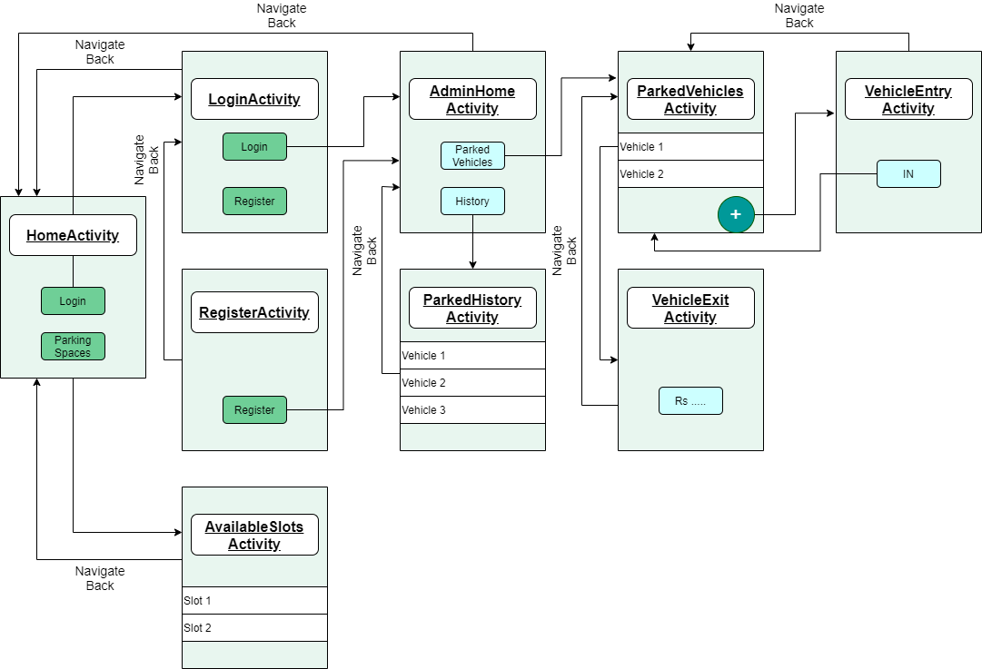

Fig. 2.3.2 Design of Application

The user interface (UI) for an Android app is built as a hierarchy of layouts and widgets. The layouts are View Group objects, containers that control how their child views are positioned on the screen. Widgets are View objects, UI components such as buttons and text boxes.

The Application is designed using the components of android such as, Layouts, Buttons, Text Views, Edit Texts, Card Layouts etc.

The above figure gives a brief design of the application and its flow. The app is designed using Constraint Layout which is a View Group containing many Views such as Edit Texts, Buttons etc.

The Constraint Layout gives the option of constraining the views with respect to the parent i.e., View Group or other Views in the layout.

The List View is designed using a Recycler View, which is been loaded with data with the help of adapters which acts as a bridge between the View and the underlying data.

These are used in AvailableSlotsActivity, ParkedVehicleActivity, ParkedHistoryActivity.

**2.4 RESULTS**

|  |  |  |
| --- | --- | --- |
|  |  |  |
| Fig. 2.4.1 Home Activity |  | Fig. 2.4.2 Admin Home Activity |
|  |  |  |
|  |  |  |
| Fig. 2.4.3 Login Activity |  | Fig. 2.4.4 Register Activity |

|  |  |  |
| --- | --- | --- |
|  |  |  |
| Fig. 2.4.5 Available Slots Activity |  | Fig. 2.4.6 Parked Vehicles Activity |
|  |  |  |
| Fig. 2.4.7 Parked History Activity |  | Fig. 2.4.8 Add Vehicle Activity |
|  |  |  |
| Fig. 2.4.9 Remove Vehicle Alert Dialog |  | Fig. 2.4.10 Vehicle Exit Activity |

|  |  |  |
| --- | --- | --- |
|  |  |  |
| Fig. 2.4.11 Add Vehicle Alert Dialog |  | Fig. 2.4.12 Forgot Password Alert Dialog |

**CHAPTER-3**

**CONCLUSION**

1. The parking management system app is effective in detecting the available parking slots through real-time data collection.
2. In addition to that the app can be a part of a bigger revolution by reducing the traffic in a city by informing the user about the parking spaces.
3. The manual process of entering the vehicles in the vehicle register book is eliminated.
4. Further enhancement is required to make the user view his or her nearby parking areas.
5. Overall system can handle all the requests from the User to give a fresh digital look for current parking management system

**REFERENCES**

[1]. M. Owayjan, B. Sleem, E. Saad and A. Maroun, "Parking management system using mobile application," 2017 Sensors Networks Smart and Emerging Technologies (SENSET), 2017, pp. 1-4, doi: 10.1109/SENSET.2017.8125048.

[2]. C. Ng, S. Cheong, E. Hajimohammadhosseinmemar and W. Yap, "Mobile outdoor parking space detection application," 2017 IEEE 8th Control and System Graduate Research Colloquium (ICSGRC), 2017, pp. 81-86, doi: 10.1109/ICSGRC.2017.8070573.

[3]. B. K. Patil, A. Deshpande, S. Suryavanshi, R. Magdum and B. Manjunath, "Smart Parking System for Cars," 2018 International Conference on Recent Innovations in Electrical, Electronics & Communication Engineering (ICRIEECE), 2018, pp. 1118-1121, doi: 10.1109/ICRIEECE44171.2018.9008662.